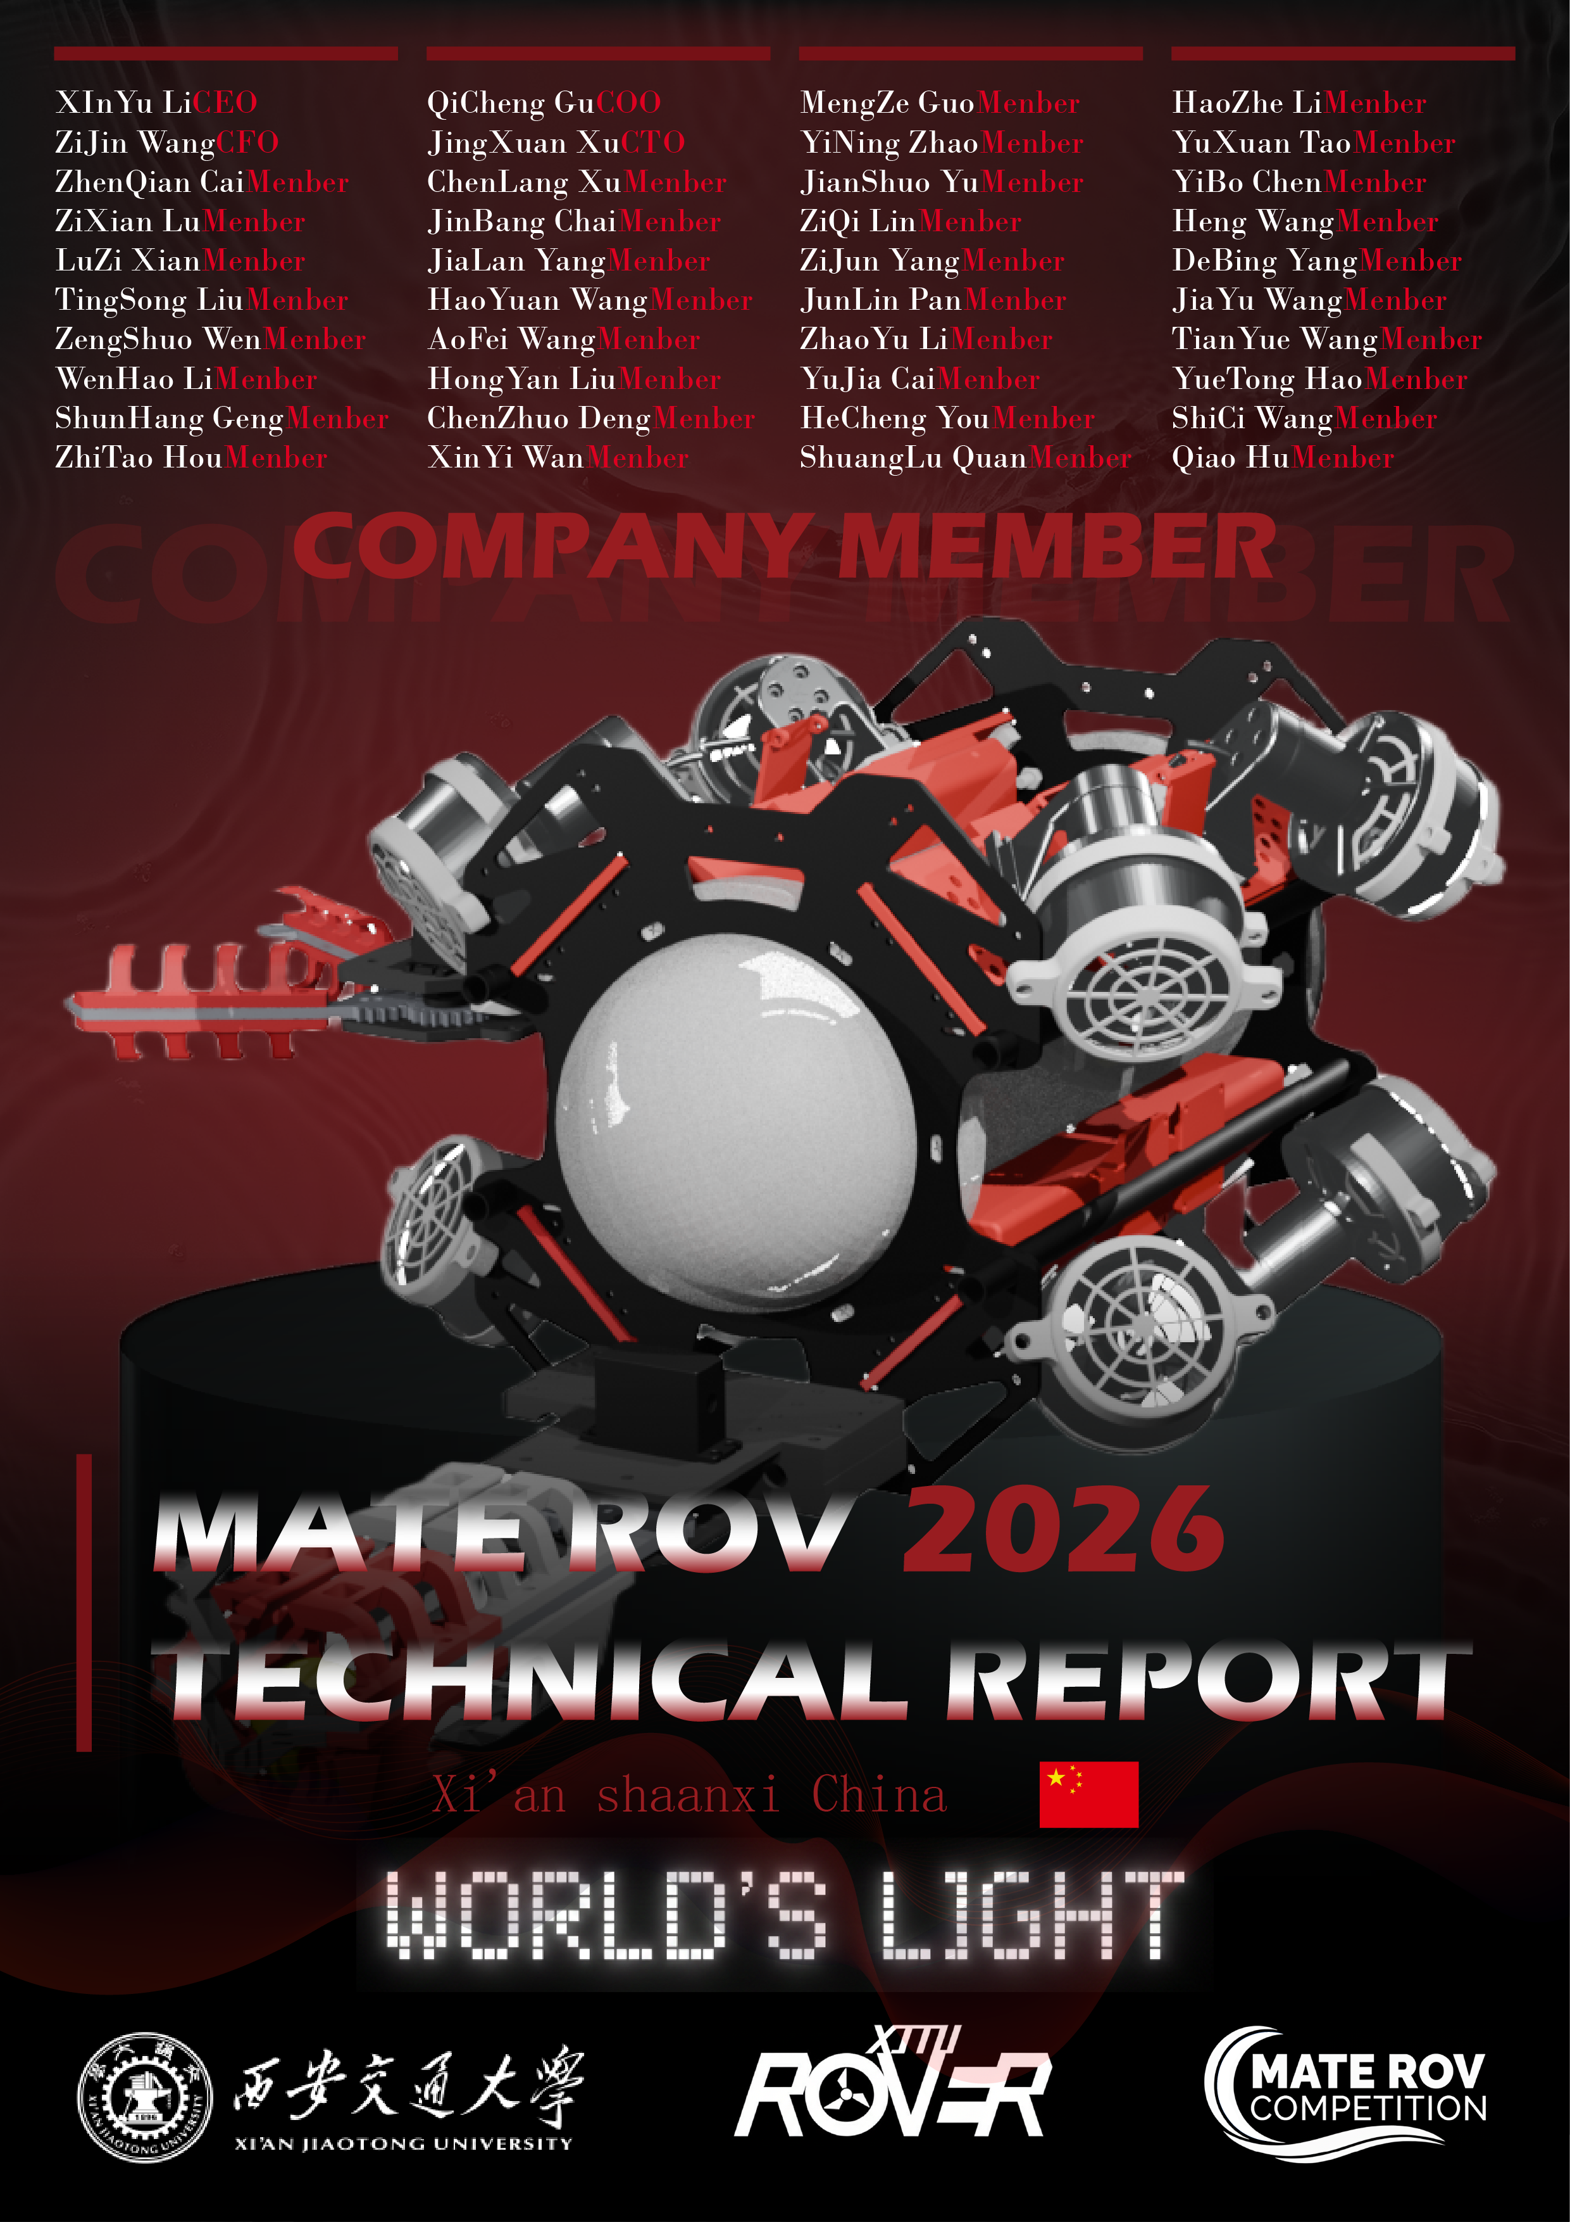

**Contents**

Abstract 3

Teamwork 3

A. Team Introduction and Key Representatives 3

B. Project management 5

Engineering Design Scheme 6

A. Mechanical Design 6

1. Whole warehouse layout design 6

2. Waterproof design 6

3. Dynamic layout design and CFD analysis 7

4. Design principle of the main mechanical gripper 8

5. Mounting Tool Design 8

B. Electronic control system 9

1. External power supply 9

2. In-cabin power transformer 9

3. Cabin layout and wiring 10

4. Main controller and its supporting peripherals 11

5. Electronically controlled power actuator 11

6. Overall control system and anti-turbulence PID design 12

7. Overall machine code execution logic 13

8. ROV-SID 14

C. Visual solutions 15

1. Visual solutions for 3D reconstruction 15

2. Visual solutions for underwater ranging 15

3. Image recognition 16

Company safety review 16

A. Laboratory Safety 16

B. Safety measures and procedures for implementing safety 17

C. Testing and Troubleshooting 18

1. Waterproofing test 18

2. Circuit continuity test 18

Financial Reports 19

A. Budget 19

B. Cost Accounting 19

Acknowledgements 20

References 21

Appendix 1: Bill of Materials 22

Appendix 2: Safety Checklist 23

Abstract

This technical document comprehensively summarizes the research results and engineering practices of the Xi'an Jiaotong University World's Light team during their preparation for the 2026 MATE Underwater Robotics Competition. Focusing on the competition's requirements, the document systematically elaborates on the core technologies of this underwater robot, including mechanical structure design, electronic control system development, and visual recognition algorithm implementation.

Regarding the mechanical structure, the team adopted a modular framework design, improving the ROV's environmental adaptability and operational stability by optimizing underwater hydrodynamic performance and hull sealing technology. The electronic control system, independently developed based on an embedded platform, achieved precise attitude control and efficient data transmission. The vision system, relying on 3D reconstruction and visual ranging technology, completed the tasks of underwater target identification, localization, and environmental perception.

This solution fully embodies the sustainable development concept of resource recycling, prioritizing the reuse of leftover materials from previous competitions for key components, effectively reducing manufacturing costs. The overall system testing and software development were all completed independently by the undergraduate team, demonstrating the team members' solid professional skills, efficient technical integration capabilities, and outstanding innovative practical level. The document also includes system design drawings, circuit schematics, algorithm flowcharts, and test data, comprehensively presenting the technical overview and engineering implementation path of this competition project.

Teamwork

## Team Introduction and Key Representatives

The "World's Light" team, formed by the Rover Underwater Robotics Club of Xi'an Jiaotong University, will represent the university in the 2026 MATE Underwater Robotics Competition. The team comprises 40 members, including two instructors, boasting strong capabilities and extensive experience. For three consecutive years, the team has participated in the highest-level (explorer level) MATE China competition, achieving remarkable results: winning first place in 2023 and 2024, and securing third place in 2025. This year, the team will once again set off with renewed vigor, striving for even greater success and continuing its glorious legacy in this competition.

The team consists of eight core members and over forty other members, comprehensively covering key technical areas such as technical documentation, robot construction and testing, and marketing, demonstrating outstanding teamwork and professional competence.

The team leadership comprises CEO Li Xinyu, COO Wang Zijin, CFO Gu Qicheng, and CTO Xu Jingxuan. CEO Li Xinyu oversaw the overall situation, guiding the team with a clear strategic vision; COO Wang Zijin was fully responsible for project operation and management, and as a core member, deeply involved in technical coordination and process advancement; CFO Gu Qicheng meticulously controlled the financial budget, providing a solid guarantee for the efficient operation of the project; CTO Xu Jingxuan led technical research and development and system integration, leading the team to overcome many core challenges. Under the coordination of these four core members, the team built a backbone system covering the entire technology chain: the technical documentation manager ensured the standardization and completeness of project materials; the mechanical structure and electronic control system backbone led robot construction and hardware integration; the visual algorithm backbone was responsible for tackling underwater target recognition and positioning technology; and the system testing backbone ensured the overall performance and operational stability of the robot.

Eight core members performed their respective duties and worked together, using solid professional skills and efficient execution to drive the team to continuously break through in technical research and development and engineering practice, providing strong leadership and support for the successful preparation of this MATE competition. The following are the eight main players of this team.

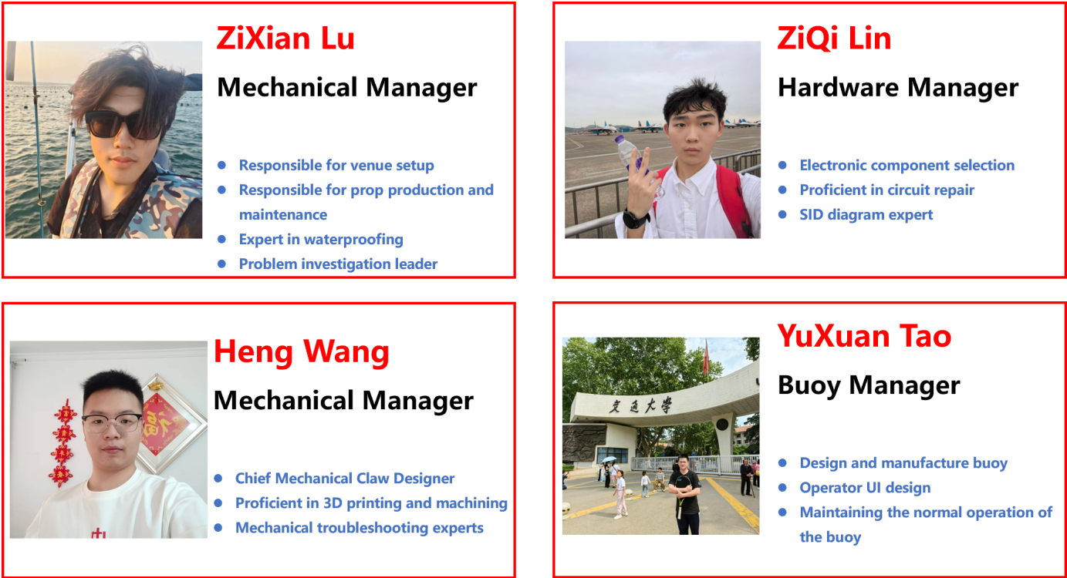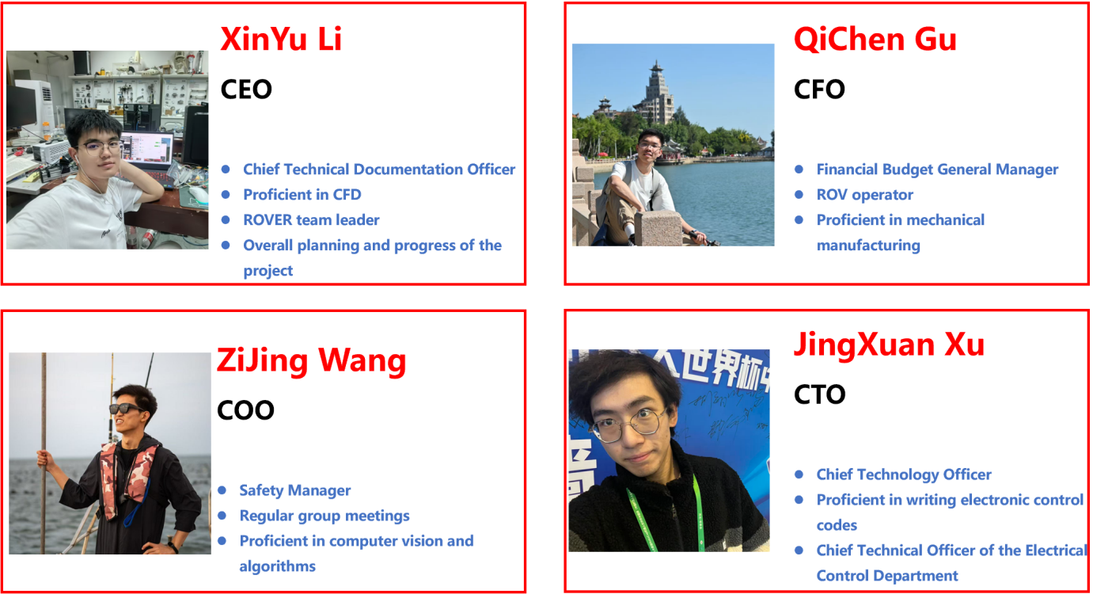

## Project management

The World's Light team has established a project-based organizational structure aligned with modern corporate systems to coordinate project progress. This three-tiered management approach enhances product innovation and R&D quality.

The first tier (decision-making level), comprising the CEO and mentors, manages strategic direction. The second tier (management level) includes technical and administrative departments that coordinate third-tier departments and report to decision-makers. The administrative department oversees technical documentation, art, procurement, security, and finance; the technical department manages mechanical, electronic control, vision, theoretical, and buoyancy divisions.

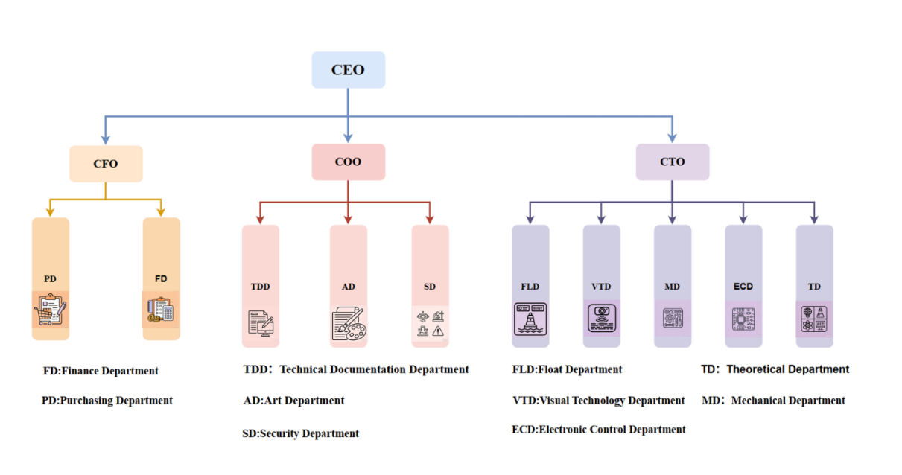The third tier (execution level) features clear departmental responsibilities: Technical Documentation manages MATE competition documents; Art handles design and configuration optimization; Procurement manages component purchasing; Safety oversees laboratory and ROV compliance; Finance controls budgets; Mechanical processes ROV structures and mission props; Electronic Control designs control systems; Vision focuses on 3D reconstruction and ranging; and the independent Buoy department manages the buoy mission.

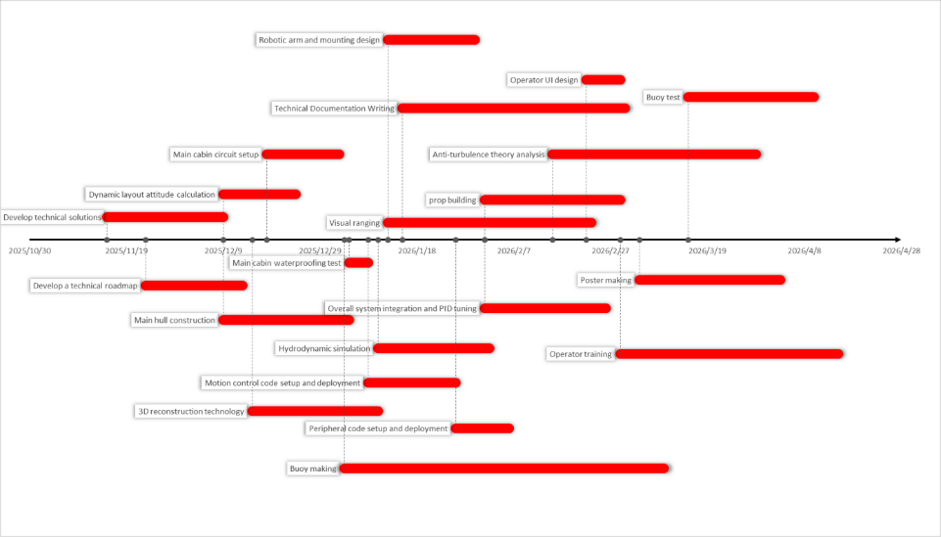To ensure timely, high-quality progress, decision-making and management teams developed a systematic project timeline. Based on strategic goals, they created a detailed Gantt chart covering the entire preparation process. Regular team meetings rigorously monitor progress, with tasks assigned to specific individuals with deadlines, guaranteeing timely advancement.

.

Engineering Design Scheme

## Mechanical Design

1. Whole warehouse layout design

For the MATE 2026 season, the ROVER team proposed a full-vector motor layout based on their mature clamp-type architecture, achieving full-degree-of-freedom control, high thrust output, and flexible mounting. Building on last year's experience, they optimized the thruster layout and adapted the mechanical gripper to better meet competition requirements.

The team retained the clamp-type frame design, connecting carbon plates and tubes for efficient cabin space utilization and flexible mechanism mounting, balancing iteration speed with scalability.

Overall assembly dimensions are strictly controlled at 742.15×537.27×274.26 mm, fully complying with MATE size limits and verified through training to avoid mission interference. The thruster aspect ratio of 1.52 significantly improves stability compared to the initial version. CFD analysis confirms thrust output aligns with theoretical values, though body-induced vortices introduce inherent disturbances.

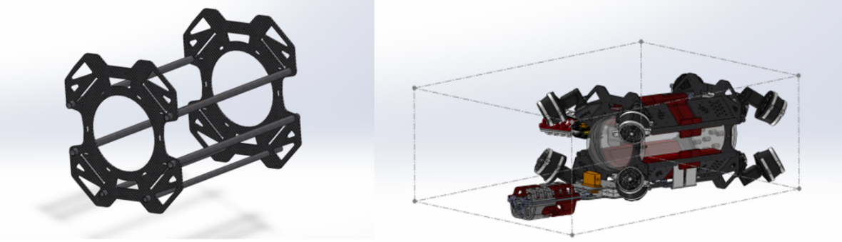To address front robotic arm self-weight torque and side wing mechanism strength requirements, middle and lower carbon tubes use 8mm/10mm and 10mm/12mm inner/outer diameter specifications respectively. With carbon fiber Young's modulus reaching 230–340 GPa (several times that of steel and aluminum), the design avoids redundancy and cost waste while meeting competition and deep-sea operation strength requirements.

1. Waterproof design

The waterproof compartment consists of three parts: a hemispherical front panel, a cylindrical hull, and a rear panel. The front panel and hull are made of acrylic. The spherical structure combined with acrylic allows the main compartment to withstand water pressure up to 20 meters (approximately 300 kPa). The rear cover is made of fiberglass for enhanced strength.

Regarding the waterproofing of wiring entering and exiting the compartment, we use a composite structure of wiring screws and aviation connectors. The wiring screws are IP68 waterproof, and the nickel-plated brass housing offers excellent aging resistance, making it suitable for extreme environments such as high temperatures, high pressures, and corrosive waters. The aviation connectors allow for quick removal and installation during maintenance, inspection, and adjustment, balancing waterproofing with portability. We use O-rings as a crucial waterproofing structure, and epoxy resin fills the waterproof joints and the contact area between the wiring screws and the rear 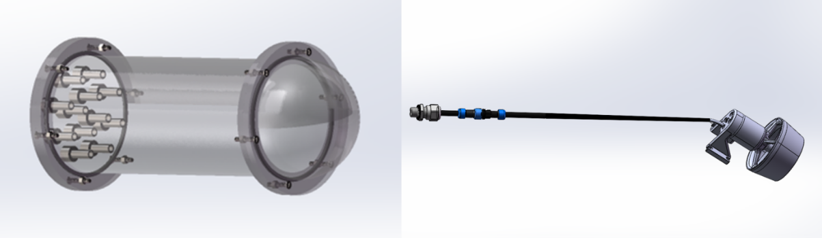cover to improve the compartment's seal, resulting in a simple and aesthetically pleasing design.

1. Dynamic layout design and CFD analysis

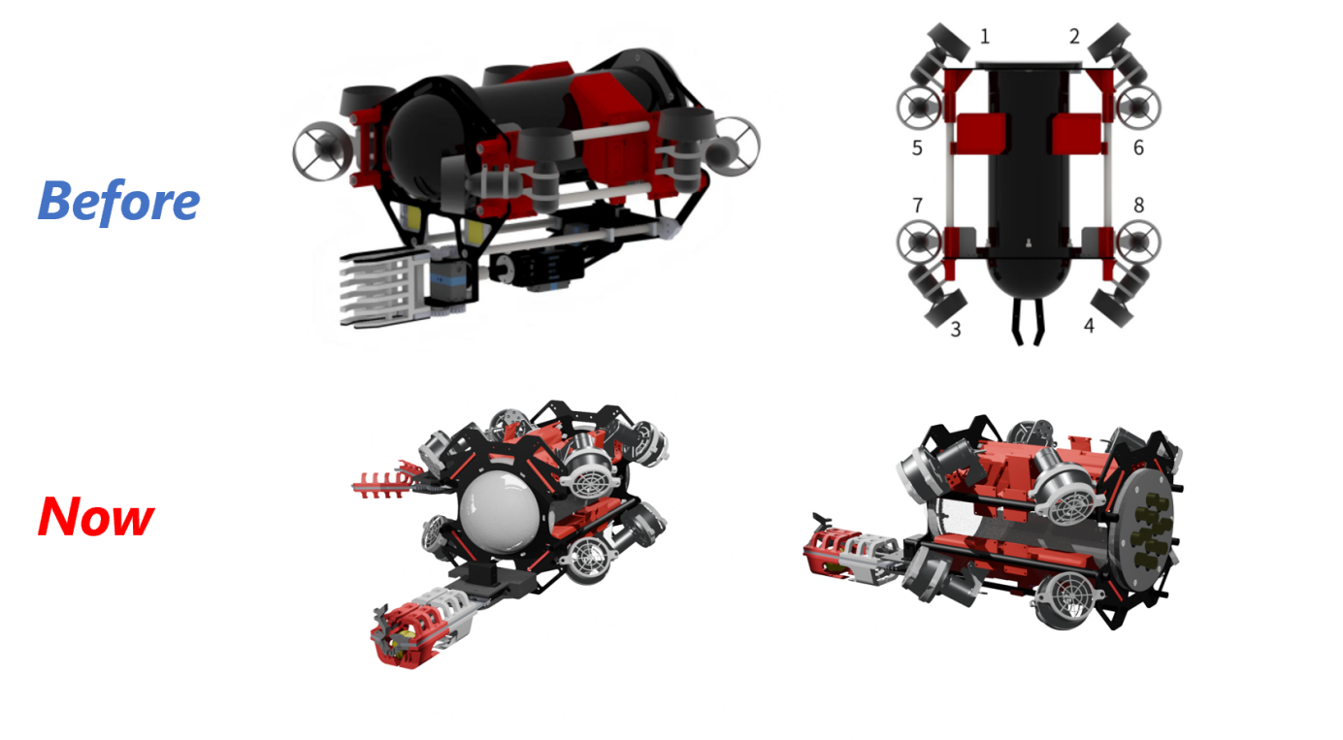In this competition, the ROVER team innovatively adopted a full-vector eight-thruster layout, departing from the conventional eight-thruster configuration. Through motor hydrodynamic simulation and experimental verification, this layout achieves omnidirectional movement freedom while delivering significant power improvement. Simulation results and dynamic vector synthesis analysis demonstrate that this layout reduces water resistance and achieves 266% of the thrust of the conventional layout with identical motor power.

In the conventional layout, motors 1-4 handle forward/backward propulsion, while motors 5-8 manage surfacing/diving. By contrast, the full-vector layout enables each motor to contribute to pitch, roll, and yaw control, as well as power for surfacing, diving, forward, and backward movements. This provides hardware support for stable robot control and efficient response.

We used ANSYS Fluent to verify motion reliability in low-to-medium speed scenarios. Simulations at 0.5 m/s, 1 m/s, and 1.5 m/s revealed minor tail eddies during forward movement, but their magnitude remained small relative to operating speed. The resulting drag force, calculated at approximately 35 N, is minimal compared to motor-generated forward propulsion. Total drag originates from the ROV and water resistance.

1. 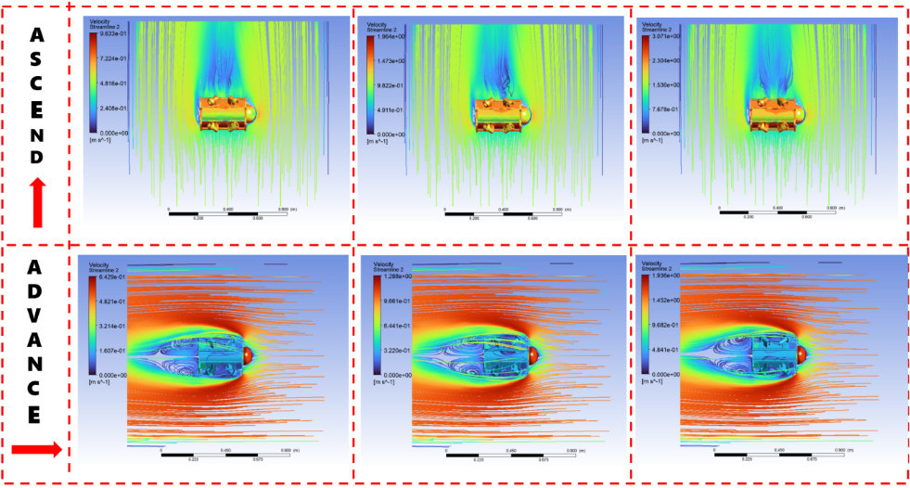Design principle of the main mechanical gripper

The ROVER team's main robotic arm utilizes an iteratively developed single-degree-of-freedom gear transmission platform, featuring a "one-drive, three-gripper" solution: one transmission platform and three quickly interchangeable specialized grippers.

The transmission system employs a Nangu NS335 brushless underwater servo motor with 35 kg·cm high torque, ensuring gripping capability for heavy objects while the brushless design extends underwater lifespan. A dedicated DC-DC step-down module provides stable 7V power, preventing voltage drops during sudden load changes. The spur gear pair (module 2, 20 teeth, 5 mm width) has been repeatedly verified to meet underwater operational load requirements.

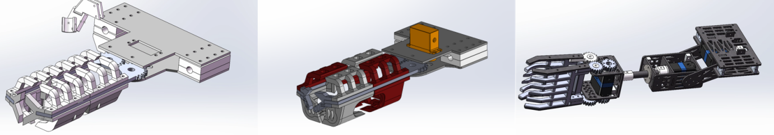The innovation lies in the gripper end. Through customized additive and subtractive manufacturing, three specialized gripper types address distinct scenarios: gripping irregular components, holding spheres/soft objects, and precision operations. All three share the same gear transmission interface, enabling plug-and-play replacement with sub-second switching. The servo motor controls angle, gear transmission, and toothed frame operate in tandem, achieving both precision and versatility.

1. Mounting Tool Design

For the 2026 MATE competition, the team designed two mounting systems: a side-mounted auxiliary mechanical claw and a bottom spring-loaded buckle structure.

The side-mounted auxiliary mechanical claw targets the "Maintenance of the Hollirud Seafloor Observatory" task. It features a single rotational degree of freedom, comprising an APISQUEEN 2828 brushless waterproof motor and a rotating fixed structure. Paired with a Mamba F55 A128K ESC, the motor operates with low-speed, high-torque characteristics. Connected to a 24V power grid with STM32 closed-loop speed control, it enables precise rotational operations. During use, the auxiliary claw rotates at high speed, clamping the PVC pipe between the fixed structure columns to complete rapid rotation of the inner plate. This solution is simple, efficient, and cost-effective.

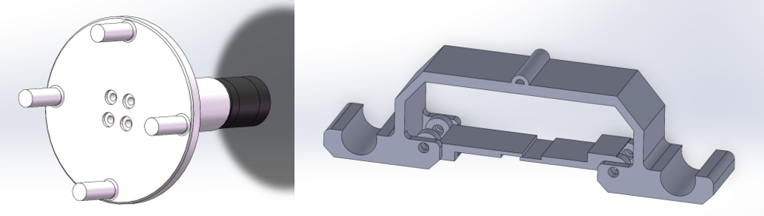The bottom spring-loaded buckle structure addresses the "Recovery of Buoy Anchors" task. It consists of a U-shaped bolt fixing seat, fixing plate, stainless steel plug screws, and a V-shaped rotating stainless steel torsion spring, forming a closed mechanism mounted on the bottom carbon fiber tube. "When the ROV descends, the device makes contact with the U-shaped bolt, and the elastic deformation of the torsion spring locks the U-shaped bolt into the mechanism. When the upward pulling force exceeds the deformation threshold, the device separates from the machine, completing the rope retrieval."

## Electronic control system

1. External power supply

This system employs a unified shore power supply scheme, with the input end provided by a 1000W AC/DC regulated power supply offering 24V–48V output. In accordance with the MATE competition's ELEC-005E step-down standard, both the shore and umbilical cable ends utilize a non-step-down direct-through design to maintain 48V high-voltage transmission, thereby improving efficiency and reducing line losses.

To meet the mandatory overcurrent protection requirements of ELEC-NRD-004, the system deploys an Anderson connector and fuse protection module adjacent to the positive output terminal of the shore power supply (<5cm). Based on peak current and rated power simulation calculations, a Littelfuse 0495040.ZXA (30A) slow-blow fuse is selected, compliant with competition certification. The shore output terminal is coupled to the umbilical cable via an XT60 high-density connector, ensuring low contact resistance and high mechanical reliability.

1. In-cabin power transformer

To balance the high power demands of the actuators with the low power consumption and stability of the control system, this system adopts a multi-stage DC-DC converter architecture, strictly adhering to the ELEC-005E standard, with zoned, tiered power supply:

First-stage step-down (main propulsion): 48V→24V, driving the thrusters and high-power actuators.

Second-stage step-down (logic control): 24V→5V, providing regulated power to the underlying controllers and sensors;.

Auxiliary step-down (external devices): 24V→7V, meeting the voltage matching requirements of specific task modules and peripherals.

This architecture achieves electromagnetic isolation and noise suppression between the power circuit and the logic circuit, ensuring the electrical safety and operational accuracy of the ROV under complex operating conditions.

1. Cabin layout and wiring

The cabin features a three-dimensional transparent design that maximizes space utilization and optimizes circuit layout while enabling real-time monitoring of component status for easy debugging and maintenance.

The support plate, manufactured via 3D printing, is divided into front and rear sections. The front section houses core control units (microcontroller and Raspberry Pi) with radially arranged DuPont wires for clean maintenance. The rear section contains the transformer and motor three-phase wiring connected to the rear cover, with wiring distributed along the periphery to avoid tangling. M3/M2.5 screws and nuts secure components and connect sections, with increased filler at connection points to reduce breakage risk.

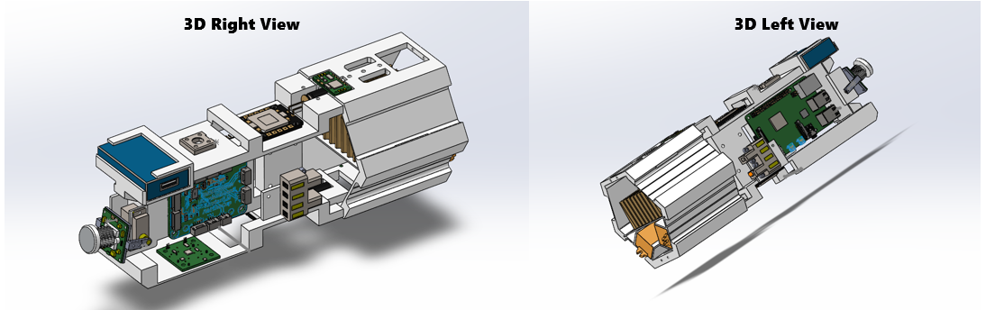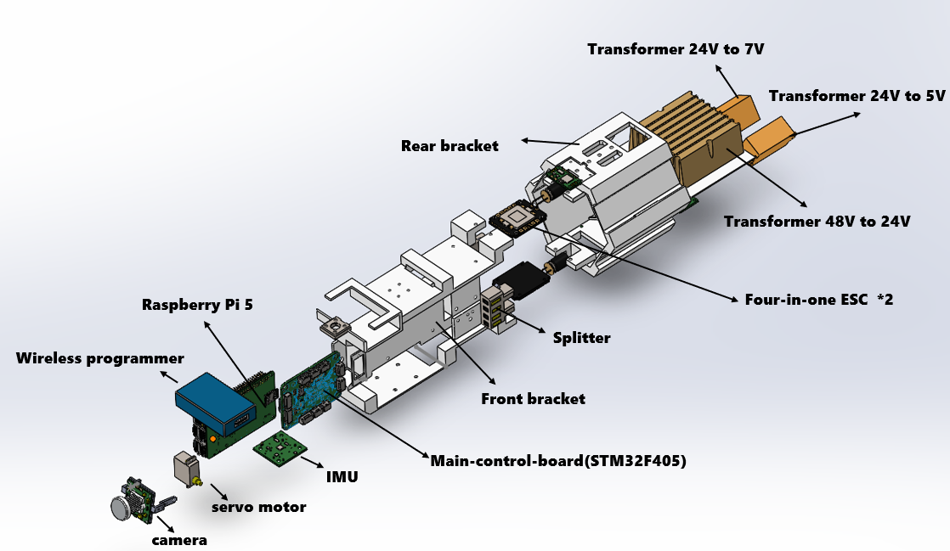A "front-to-back divide-and-conquer" strategy addresses thermal management: high-power modules (power supply, motor drive) concentrate at the rear, while sensitive devices (main control unit, sensors) reside at the front. This physical separation suppresses high-frequency crosstalk from power circuits to logic signals.

The pressure-bearing structure uses high-transmittance acrylic material. Meeting pressure resistance requirements while allowing visual inspection without disassembly significantly shortens troubleshooting cycles.

1. Main controller and its supporting peripherals

The main control decision layer adopts a heterogeneous architecture of Raspberry Pi 5 + STM32F405RGT6, balancing high-performance computing power with microsecond-level real-time control. The Raspberry Pi handles visual algorithms, video stream transmission, depth calculation, and ground station TCP/IP communication; the STM32 utilizes rich peripheral interfaces (UART/I2C/TIM) to achieve precise actuator drive.

The inertial navigation unit uses the Hiwonder high-precision attitude sensor, integrating a three-axis gyroscope, accelerometer, and magnetometer. Built-in fusion algorithms effectively suppress MEMS zero drift and are specifically optimized for motor magnetic field interference, enabling stable Euler angles to be output to the STM32 via I2C in high-magnetic and metal pipe environments.

The depth gauge uses a TE MS5837-30BA gel-protected pressure sensor with a unique direct-mount design on the rear hatch, allowing direct contact with the water without the need for an additional pressure tube. It achieves a resolution of 0.2 mbar (approximately 2 mm water depth change), and the data is converted by the Raspberry Pi to plot a depth curve in real time, providing high-precision closed-loop feedback for depth control.

1. Electronically controlled power actuator

In this year's MATE, we adopted a completely new system layout: an eight-pusher full-vector power system.

The core of the power control system consists of two sets of Mamba MK2 F55 BLS four-in-one electronic speed controllers deployed inside the cabin. These ESCs support BLHeli_S firmware and the DShot digital protocol, offering fast response and strong anti-interference capabilities, and are directly powered by a 24V DC power bus. The upper-level STM32 main controller independently controls four thrusters each on the upper and lower sides of the cabin via PWM/DShot signals, collectively creating a 6-DOF omnidirectional motion capability.

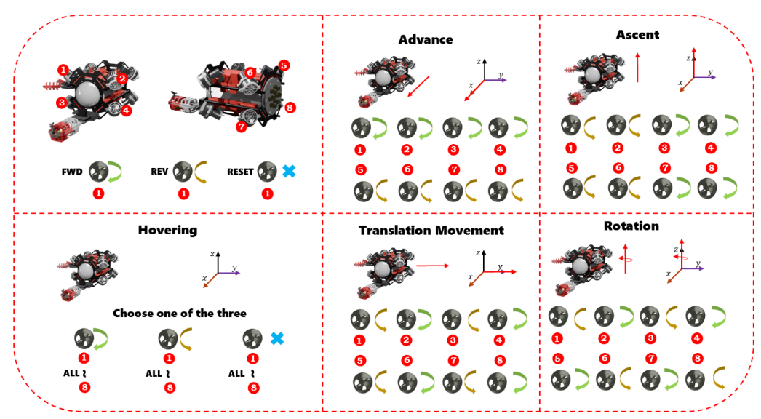The figure below shows the thruster response timing when the robot performs a typical motion. It should be noted that the actual motion posture is influenced by multiple factors, including PID closed-loop control and hydrodynamics; only the most basic open-loop control logic and thrust distribution relationship are presented here.

1. Overall control system and anti-turbulence PID design

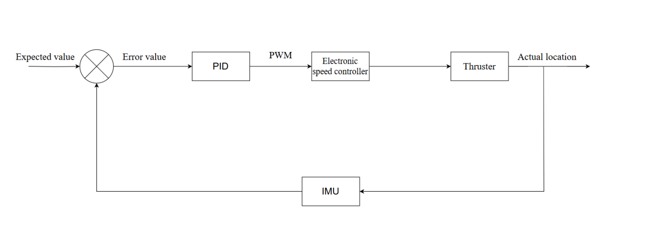To achieve stable control of ROV attitude (yaw, pitch, and roll), we constructed a closed-loop control system based on a single-loop PID controller, following the "sensing-decision-execution" automatic control logic. The system operates with the ROV as the controlled object in environments subject to water flow and fluid resistance variations. Gyroscopes provide real-time attitude angle feedback, which, together with the target attitude (e.g., maintaining a 0° heading) from the remote controller, generates a deviation signal. This deviation is processed by the single-loop PID controller, and the resulting control output, after power distribution, drives the eight thrusters, completing the closed-loop regulation.

For smooth and stable ROV operation while meeting mission requirements, we retained single-loop PID control as the core solution for the motion control system. Compared to complex alternatives, single-loop PID offers low cost, simple control logic, and easy code maintenance. Despite significant changes to the overall ROV configuration this year, we chose this mature architecture to ensure efficient PID debugging and system integration within the limited project timeline. The system block diagram is provided below.

We employed a system modeling approach, combining theoretical analysis with MATLAB simulation to generate theoretical schematics such as Bode plots, Nyquist plots, root locus curves, and step responses. These schematics were used to verify system stability and assist in PID parameter tuning. The figure below shows the Bode plot, Nyquist plot, step response, and root locus curves generated in this simulation.

PID Parameter Optimization: Appropriately increasing the derivative coefficient allows the system to detect attitude change trends in advance and quickly output compensation to suppress sudden water flow disturbances; a reasonable integral coefficient can eliminate static heading deviations caused by continuous water flow, while limiting integral saturation to prevent thruster output from exceeding limits.

System Bandwidth Matching: The control bandwidth is designed to be 0.5~5 Hz, consistent with the ROV's response characteristics. Low-frequency disturbances below this bandwidth (such as slow water flow) are eliminated by integral action, while high-frequency disturbances above this bandwidth (such as turbulence) are naturally filtered out by the derivative element and system inertia.

Software and Hardware Auxiliary Measures: Moving average filtering is applied to gyroscope data to remove high-frequency noise from sensors; thruster output is limited (e.g., PWM range 1100~1900) to avoid power imbalance caused by single thruster overload, indirectly improving overall anti-interference capability.

1. 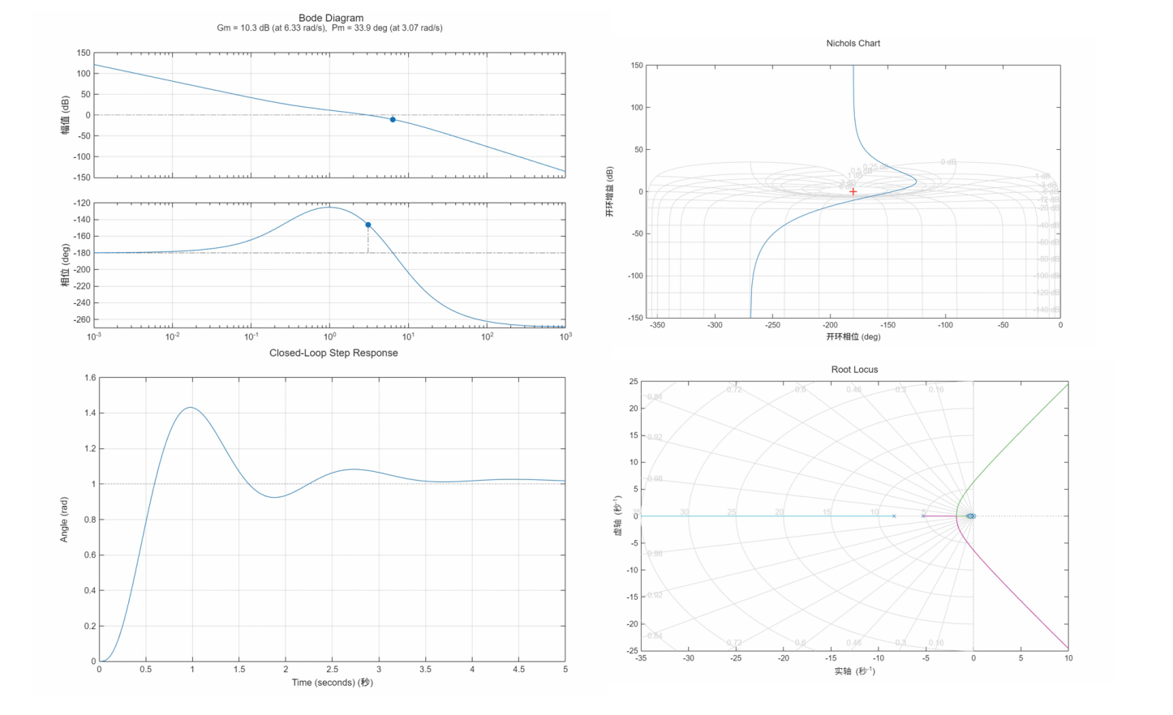Overall machine code execution logic

The system runs on an STM32F405RGT6 microcontroller using the HAL library. The software architecture comprises initialization and main loop phases, structured into input and execution output layers.

During initialization, peripherals are configured: GPIO modes, USART1 (9600 baud, connected to remote control) and USART2 (9600 baud, connected to gyroscope) with receive interrupts enabled, and TIM1/TIM8 timers configured to output 50Hz PWM for thrusters and servos. Core parameters are then initialized, including PID controllers for yaw, pitch, and roll channels, with thruster PWM reference values set to 1500 and output limited to 1000-2000. Finally, gyroscope zero-bias calibration and attitude calculation are initialized.

The main loop runs at approximately 10ms intervals, polling received data via serial interrupt callbacks. USART1 receives target attitude and motion commands from the remote controller, while USART2 receives real-time attitude angles from the gyroscope, with CRC checks filtering invalid data. After calculating deviations for each attitude channel, the PID_Calc function generates control quantities. These are distributed to the eight thrusters based on the ROV's power layout, with translation commands from the remote controller superimposed. Servo control, if required, calculates corresponding PWM values based on attitude deviation. All thruster outputs are then limited to 1100-1900 and written to timer CCR registers to drive the thrusters.

The input layer handles system initialization, peripheral configuration, PWM startup, and receiver signal acquisition. It receives host computer data frames via serial interrupts, buffers them in RcDataCache, and parses them through RC Translate to generate RCkey control instructions. The system continuously updates angle measurements and IMU data, checking IMU readiness and RC power status within the 10ms main loop.

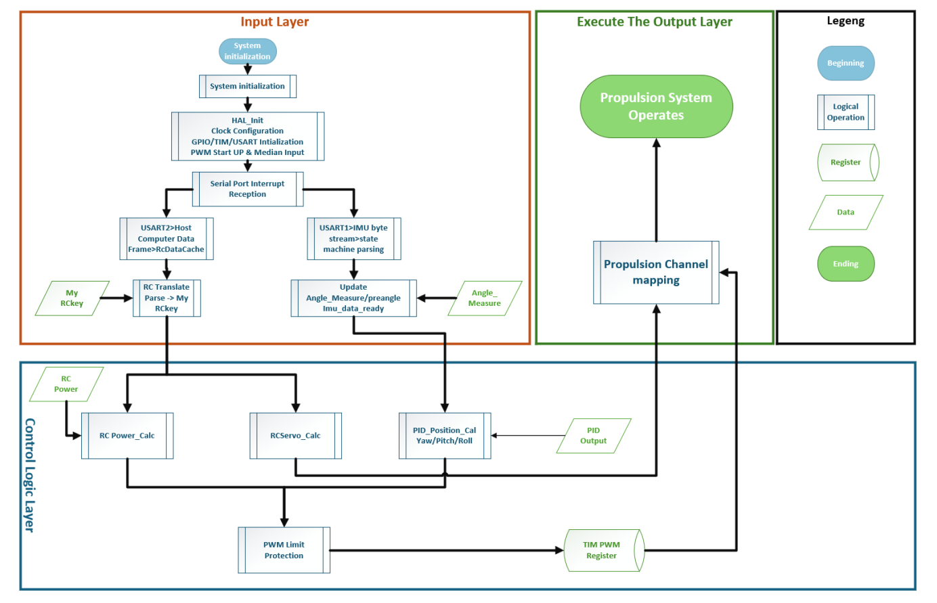The execution output layer translates parsed instructions into thruster actions. Through channel mapping, it performs mixed control calculations on PID-generated Yaw, Pitch, and Roll outputs, producing independent control signals for thrusters 1-8. These outputs are written to TIM PWM registers and, after limiting protection, drive the propulsion system.

1. 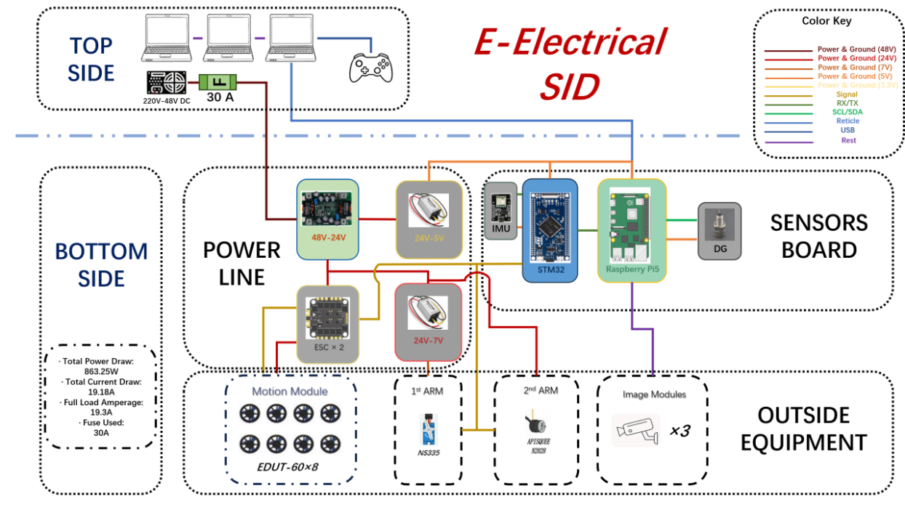ROV-SID

## Visual solutions

1. Visual solutions for 3D reconstruction

For the visual task in the MATE competition, we selected 3D Gaussian Splatting (3DGS) for its superior reconstruction speed and accuracy. The workflow begins with video preprocessing, where an interleaved frame extraction strategy converts underwater video into a high-quality image sequence to support multi-view reconstruction. Frames are divided into two groups based on index parity, with one group enhanced to improve detail, providing rich data for subsequent steps.

The processed images then undergo COLMAP-based reconstruction, where SIFT feature extraction and sequence matching are used to generate camera poses and sparse point clouds. This method reduces computation while ensuring accurate feature correspondence. The extracted data is then fed into the 3DGS algorithm, which represents the scene using anisotropic Gaussian primitives and employs differentiable rendering to align with real images, achieving high-quality 3D reconstruction and novel view synthesis.

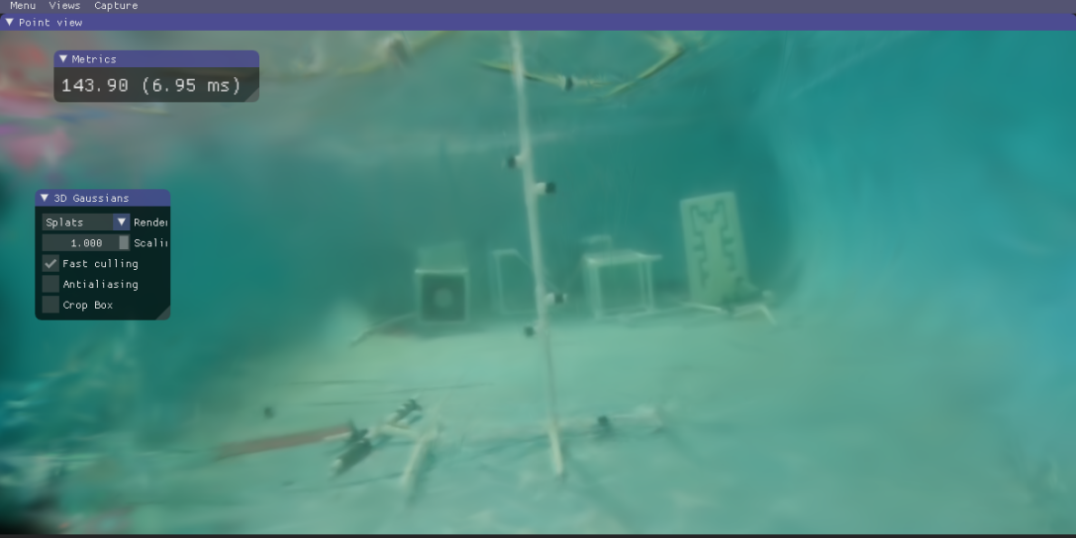With these optimizations, the pipeline achieves fast reconstruction—completing the entire process for a 50-second underwater video in about six minutes on a single GPU. Additionally, effective viewpoints increased from 17 to around 40, strengthening multi-view constraints and improving reconstruction stability. The final model demonstrates enhanced edge continuity, finer texture details, and better integrity in occluded areas, proving its effectiveness in complex underwater environments.

1. Visual solutions for underwater ranging

For the ranging task, we employed the SGBM (Semi-Global Block Matching) algorithm. Based on binocular vision geometry, it calculates depth by determining disparity, improving upon the traditional BM (Block Matching) algorithm. While BM estimates disparity locally by sliding fixed windows to find similar matches, it suffers from noise, occlusion, and weak texture regions, producing fragmented disparity maps. Global methods offer smoother results but at higher computational cost. SGBM balances efficiency and accuracy by introducing smoothing constraints and aggregating cost information across multiple directions, achieving near-global optimization with low overhead.

In performance validation, we first tested SGBM on land. Using 50 calibration image sets, we obtained camera distortion parameters and achieved initial measurement errors within 5 cm. After optimizing sampling distance, angle, and expanding the sample database, we reduced the error to within 2 cm. We then conducted underwater tests using a binocular waterproof camera. Following the same calibration process to correct underwater distortion, we performed ranging on stationary objects, consistently maintaining measurement errors within 3 cm. These results demonstrate the 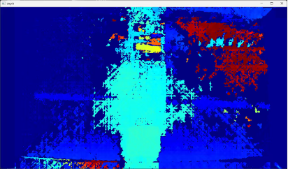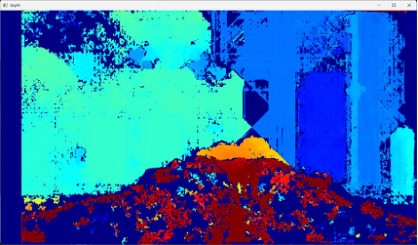algorithm's accuracy and adaptability in underwater environments.

1. Image recognition

For this MATE image recognition task, we adopted an OpenCV-based image processing approach. Since the colors of the objects being identified differed significantly, we employed a color filtering approach. The specific process is as follows:

(1) Read the image, scale it, then use Gaussian blur for noise reduction, and finally convert the image from BGR format to HSV format for easier color extraction.

(2) Extract the target region based on the defined dark green HSV range, generate a mask image, and then remove small noise points using opening operations. Finally, connect the scattered crab fragment outlines using closing operations.

(3) Search for all contours in the mask. First, filter out contours with too small an area to reduce interference from misidentified blocks of similar colors from other crab types. Then, use compactness filtering to find contours with relatively reasonable shapes.

(4) Calculate the center coordinates of each valid contour. Perform clustering operations based on the distance between the centers, grouping contours that are close together into the same group, representing the same crab.

(5) Calculate the total area for each cluster and determine if it reaches the set minimum area threshold. If it does, it is considered a valid crab. For each valid crab, draw its corresponding bounding rectangle on the original image and label it with text. Simultaneously, increment the crab counter. Finally, display the recognition result image and output the number of recognized crabs on the image.

Through the above process, we can accurately measure the number of crabs and mark their locations on the screen in real time, meeting the task requirements.

Company safety

## Laboratory Safety

Safety was paramount throughout the entire MATE preparation process, covering laboratory processing, mechanical and electrical operations during preparation, and water testing. Detailed checklists and material lists were used to control risks at the source and ensure rapid and effective intervention in case of emergencies, guaranteeing the safety of personnel and equipment.

The laboratory implemented a daily parts and instrument return system, with equipment managed in three categories:

(1) Mechanical parts and processing equipment. This includes hand tools such as screws and wrenches, as well as 3D printers, and falls into a relatively safe category. Specialized training was provided to reduce the probability of accidents, and iodine and bandages were readily available in the assembly area for cuts and scrapes.

(2) Electrical parts and circuits. The 220V to 24V conversion section is hazardous; it is secured, insulated, and isolated, maintaining a safe distance of ≥0.5 meters from personnel. Low-voltage sections (≤12V) are equipped with electrostatic discharge devices to prevent electrostatic damage.

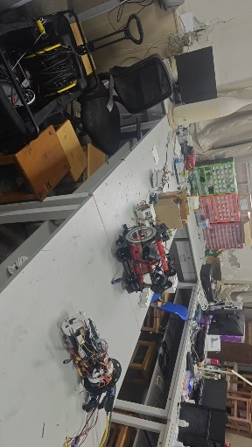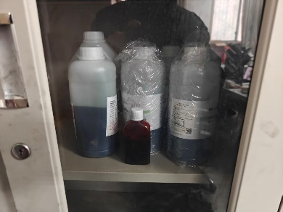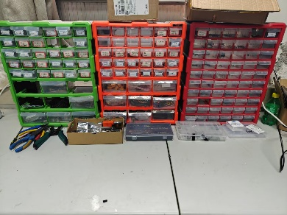(3) Chemicals. These are stored in dedicated cabinets. White protective clothing and rubber gloves must be worn during handling to prevent personal injury.

## Safety measures and procedures for implementing safety

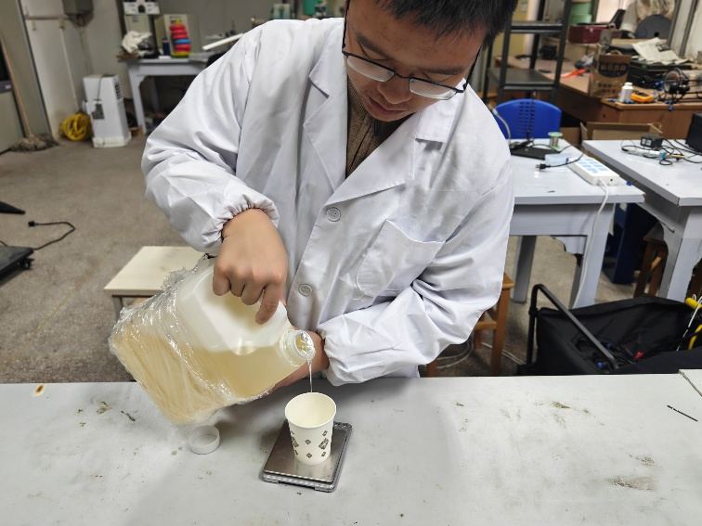During the preparation phase, we meticulously checked each item in the attached safety inspection checklist to ensure compliance with regulations at every stage. Mechanically, we thoroughly inspected all equipment surfaces and connections to ensure there were no sharp edges or protrusions; we focused on inspecting the underwater propellers, ensuring the blades were completely covered by the motor protective cover to eliminate the risk of accidental contact. Electrically, we systematically reviewed all wiring to ensure secure connections and good insulation; transformers and power conversion equipment were placed in a safe, dry, and well-ventilated area away from the water tank, with physical isolation and protection measures implemented; cable routing avoided crossing passageways, contact with water sources, or being squeezed. For emergency preparedness, we pre-stocked first-aid supplies such as iodine swabs, bandages, and sterile gauze, and all team members were familiar with the location of these supplies and completed the emergency response procedure briefing.

The water testing is a crucial step in ROV performance verification and also a period of concentrated safety risks. Before the equipment entered the water, a designated person meticulously checked each item on the inspection checklist for hatch sealing, insulation resistance compliance, propeller operation status, and the secure installation of the blade protective cover; the transformer was kept away from the water body and placed in a splash-proof area, and the power supply line was connected to leakage protection. The testing environment was designated as a separate area with warning signs, and anti-slip mats were laid around the pool. Personnel operated in pairs, using specialized tools for both entering and retrieving water. All personnel were familiar with emergency plans for power outages and falls into the water, and lifebuoys, first-aid kits, and insulated hooks were provided on-site to ensure rapid response to emergencies.

## Testing and Troubleshooting

1. Waterproofing test

Waterproof sealing is crucial for the stable operation of the ROV and the safety of the electronics compartment. A comprehensive inspection is conducted after final assembly and before launch.

Before testing, the compartment components, cover, connectors, and O-rings are inspected: surfaces are free of scratches and foreign objects; sealing rings show good elasticity; and silicone grease is applied evenly. After the compartment is closed, screws are tightened diagonally to the calibrated torque to prevent unilateral overload failure.

During the surface stage, the ROV is placed in shallow water and observed for continuous bubbles and no water vapor or signs of water ingress inside the compartment. Subsequent dynamic load testing involves continuous monitoring of humidity and insulation resistance inside the compartment during full-degree-of-freedom movement, ensuring stable values ​​and no abnormal drops. The sealed compartment must pass a waterproof test before the ROV can be manufactured and launched.

1. Circuit continuity test

Circuit connectivity is the reliable foundation for ROV power transmission and signal control. After the electrical system is assembled, a full-coverage continuity and insulation test is performed.

Before testing, cables, connectors, and terminals are inspected: wire numbers are clear, crimps are secure, there are no exposed burrs, and no incorrect connections. The power system is powered on stage by stage, and the 24V, 12V, and 5V outputs are monitored to ensure stability, normal ripple, and no abnormal overheating or false triggering of protection devices. The signal link is verified to ensure accurate command response from the thrusters, robotic arms, cameras, sensors, and other channels, clear video transmission, and continuous data feedback. During the overall system integration and debugging phase, the entire system is run under load, and the bus current and temperature rise are monitored. All modules work together normally, with no communication interruptions or resets.

Test data is recorded in real time, and any abnormalities are investigated, repaired, and retested in a closed-loop manner. Only after passing the tests can the sealing and waterproofing process begin.

Financial Reports

Due to significant exchange rate fluctuations between China and the US, we have primarily used RMB for the numbers in the charts and USD for the text. This is to facilitate a thorough review of the submitted documents by the judges in the Chinese region. Furthermore, China's price level is relatively stable, and the electronic components used in underwater robot construction have maintained relatively stable prices for a long time. Therefore, the focus of the charts is on the proportional relationships between the various parts rather than absolute numerical values.

## Budget

The total budget for this MATE China regional competition is estimated at 43,000 RMB (approximately 5,900 USD), primarily covering four parts: robot manufacturing costs, team travel expenses, competition registration fees, and cultural and creative product development.

The robot's manufacturing cost is approximately 10,000 RMB (approximately 1,370 USD). This portion of the budget will mainly be used for the purchase of the cabin structure and core hardware; related system testing and software development will be completed independently by the team's undergraduate students. The team's travel expenses are budgeted at approximately 21,000 RMB (approximately 2,880 USD). It is planned that 12 members will travel to Shanghai to participate in the competition, with round-trip airfare estimated at 14,400 RMB and accommodation budgeted at 6,000 RMB. The competition registration fee is 11,000 RMB (approximately 1,510 USD). In addition, the cultural and creative product development budget is approximately 1,000 RMB (approximately 137 USD), which will be used to design and produce exclusive souvenirs that integrate the characteristics of Xi'an Jiaotong University and the ROVER club culture.

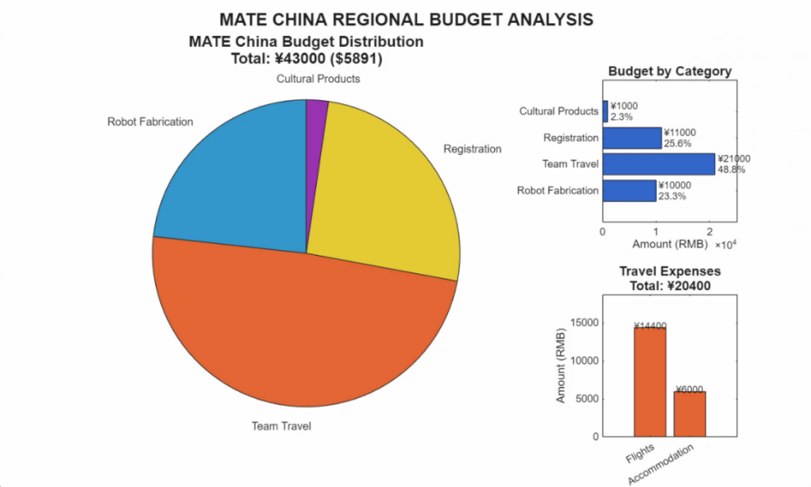Below is a chart showing the budget expenditures for this MATE China regional competition.

## Cost Accounting

The funding for this MATE China regional competition project came entirely from special grants from Xi'an Jiaotong University and instructors Quan Shuanglu and Hu Qiao. All funds were used solely for competition-related expenses, with no misappropriation.

The team actively practiced sustainable development principles, systematically reusing reusable parts from last year's MATE competition during preparation, and integrating idle components from other projects within the ROVER community. Through optimized design and adaptive modifications, the proportion of new material procurement was significantly reduced, improving resource recycling rates.

No external donations of goods were accepted for this competition. All materials and equipment were purchased through funding or provided by Professor Hu Qiao's graduate student team. Xi'an Jiaotong University's School of Mechanical Engineering provided financial support, and instructors Quan Shuanglu and Hu Qiao's team provided full-process technical consultation and guidance.

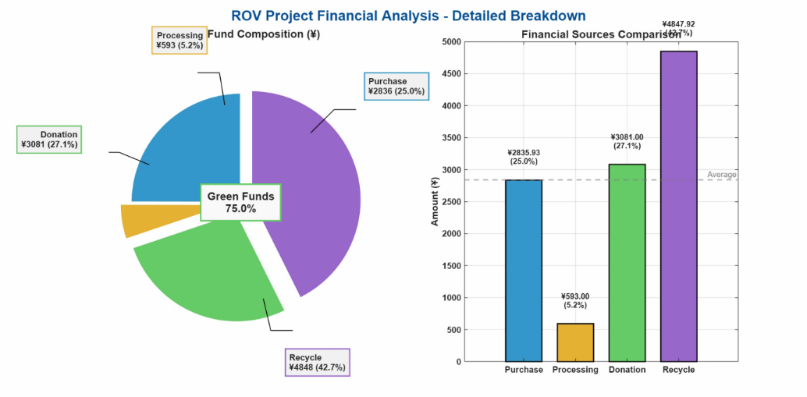While strictly controlling costs, the team earnestly implemented green preparation principles. Expenditure was closely focused on core aspects such as robot development, travel arrangements, competition registration, and team culture building, ensuring maximum efficiency and resource effectiveness. See attached figures and tables for details on the expenditure ratio and procurement list. The following is a visualization chart of the actual expenditure ratio for this MATE China regional competition. The attached table shows the procurement list for this MATE project.

According to the attached table, the total value of project materials is ¥11,357.85 ($1,564.72), of which actual procurement expenditure is ¥4,596.40 ($633.12), accounting for 40.5%; non-procurement items (processing, donation, and recycling) total ¥6,761.45 ($931.60), accounting for 59.5%. Among non-procurement items, recycled and reused materials have the highest value, reaching ¥3,537.20 ($487.22), accounting for 31.1% of the total value, and are the core contributor to cost control; donated materials are ¥1,653.00 ($227.69), accounting for 14.6%; processed materials are ¥1,571.25 ($216.43), accounting for 13.8%.

The actual cash expenditure for robots in this project is only $633.12, and green funds cover the material value of $931.60. If the hidden costs were converted into procurement, the total investment would rise to $1,564.72, nearly 1.5 times larger—meaning that green funds would save this project over $900 in hard currency expenditure. In a budget-constrained scenario, this resource integration model significantly enhances resilience and economic scalability. The team will continue to implement its sustainable development strategy, adhering to recycling and reuse as its core preparation philosophy.

Acknowledgements

As we prepare for and participate in the competition, we would like to extend our sincerest gratitude to Ms. Quan Shuanglu and Mr. Hu Qiao for their selfless support and professional guidance throughout the team. It is under their guidance and assistance that the team has been able to make steady progress in technical challenges and organizational coordination. At the same time, we sincerely thank every member of the team for their dedicated efforts and hard work over the past six months. It is everyone's tireless collaboration and unwavering exploration that has led to today's growth and achievements. Furthermore, we are deeply grateful to the MATE organizing committee for building such an excellent international exchange platform over the years, allowing young engineers from around the world to gather ideas, exchange technologies, and explore the infinite possibilities of underwater robotics.

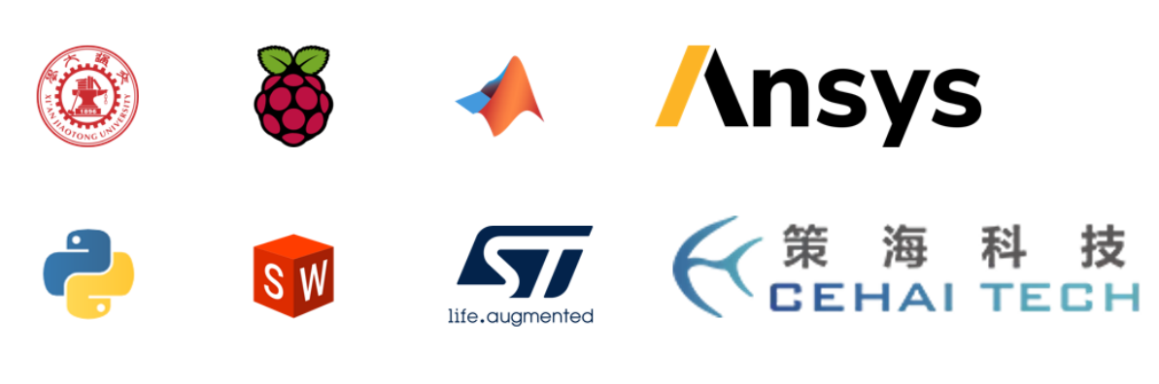On behalf of the "World's Light" team, we express our deepest gratitude to all those who have supported and accompanied us on this journey.

References

[1] T. Gao, Y. Luo, C. Lv, et al., "Model Predictive Control for an Autonomous Underwater Robot with Fully Vectored Propulsion," in *2024 IEEE International Conference on Robotics and Automation (ICRA)*, Yokohama, Japan, 2024

[2] Y. Wang et al., "A Novel Underwater Vehicle With Orientation Adjustable Thrusters: Design and Adaptive Tracking Control," *arXiv e-prints*, arXiv:2501.12345, Jan. 2025.

[3] I. Masmitja, J. Gonzalez, C. Galarza, et al., "New Vectorial Propulsion System and Trajectory Control Designs for Improved AUV Mission Autonomy," *Sensors*, vol. 18, no. 4, p. 1241, Apr. 2018, doi: 10.3390/s18041241.

[4] B. Kerbl, G. Kopanas, T. Leimkühler, and G. Drettakis, "3D Gaussian Splatting for Real-Time Radiance Field Rendering," *ACM Trans. Graph.*, vol. 42, no. 4, pp. 139:1–139:14, Jul. 2023.

[5] Z. Xu, G. Chen, F. Li, L. Chen, and Y. Cheng, "A survey on surface reconstruction based on 3D Gaussian splatting," *PeerJ Comput. Sci.*, vol. 11, p. e3034, 2025, doi: 10.7717/peerj-cs.3034.

[6] J. Zhang, F. Han, D. Han, J. Yang, W. Zhao, and H. Li, "Object measurement in real underwater environments using improved stereo matching with semantic segmentation," *Measurement*, vol. 218, p. 113147, Aug. 2023, doi: 10.1016/j.measurement.2023.113147.

Appendix 1: Bill of Materials

|  |  |  |  |
| --- | --- | --- | --- |
| item | $price | quantity | $ Total price per item |
| Underwater propulsion | 48.07 | 8 | 384.54 |
| Waterproof tank | 59.71 | 1 | 59.71 |
| Carbon fiber plate | 28.57 | 1 | 28.57 |
| Threading screws(ALL) | 14.05 | 1 | 14.05 |
| Aviation plug(ALL) | 22.06 | 1 | 22.06 |
| 3D printed parts(ALL) | 64.29 | 1 | 64.29 |
| Various types of screws and nuts(ALL) | 7.14 | 1 | 7.14 |
| Waterproof servo | 60.00 | 1 | 60.00 |
| Waterproof motor | 14.26 | 1 | 14.26 |
| Fiberglass board | 35.71 | 1 | 35.71 |
| 30A Littelfuse | 0.83 | 2 | 1.66 |
| Square fuse holder | 3.14 | 1 | 3.14 |
| Anderson plugs and their associated components | 3.51 | 1 | 3.51 |
| 2000W 50A high-power DC-DC step-down converter | 56.00 | 1 | 56.00 |
| Flame-free electronic delay switch | 17.57 | 1 | 17.57 |
| Water pressure and water depth sensor | 41.41 | 1 | 41.41 |
| IMU inertial navigation module gyroscope | 36.29 | 1 | 36.29 |
| 1000W adjustable switching power supply | 20.00 | 1 | 20.00 |
| STM32F405 | 11.86 | 1 | 11.86 |
| Power supply cables and network cables outside the warehouse | 34.00 | 1 | 34.00 |
| Raspberry Pi 5B | 76.57 | 1 | 76.57 |
| Electronic speed controller | 39.14 | 2 | 78.29 |
| Various types of transformers | 2.54 | 2 | 5.09 |
| Underwater camera outside the chamber | 421.14 | 1 | 421.14 |
| Interior front-facing camera | 68.57 | 1 | 68.57 |
| Stereo vision camera | 54.26 | 1 | 54.26 |
| Internal connection wires in the cabin | 2.86 | 1 | 2.86 |

Appendix 2: Safety Checklist

**ROVER Safety Checklist**

━━━━━━━━━━━━━━━━━━━━━━━━━━━━━━━━━━━━━━━━━━

**I. DAILY LABORATORY SAFETY**

□ All items returned to designated positions daily

□ Hand tools stored neatly, 3D printer area clean

□ First aid supplies ready in assembly area

□ 220V–24V section secure and insulated

□ High voltage area maintains ≥0.5m safety distance

□ Low voltage circuits (≤12V) no exposed wires or shorts

□ ESD protection devices installed and functional

□ Chemicals stored in locked cabinets, PPE worn

□ No spills, chemicals returned after use

**II. PREPARATION STAGE**

□ No sharp edges, thruster blades fully guarded

□ Moving parts show no jamming or abnormal noise

□ Wiring connections secure, no dangling wires

□ Transformers away from water, protected against impact

□ Cables routed away from walkways and pinch points

□ First aid supplies stocked and location known

□ Emergency procedures communicated to all members

**III. IN-WATER TESTING STAGE**

□ Seals reliable, insulation resistance test passed

□ Thrusters normal, guards secure, buoyancy stable

□ Transformer splash-proof, connected to RCD

□ Test area demarcated, unauthorized excluded

□ Pool surroundings dry, clean, anti-slip mats

□ Safety observer on duty, two-person coordination

□ Dedicated tools for launch and recovery

□ All familiar with emergency power-off and man-overboard

□ Lifebuoy, first aid kit, insulated hook ready on site

**IV. GENERAL REQUIREMENTS**

□ Safety officer assigned, daily briefing conducted

□ Issues reported immediately, records filed daily

━━━━━━━━━━━━━━━━━━━━━━━━━━━━━━━━━━━━━━━━━━

**Inspected by:** __________________________ **Date:** __________________________